5 Reasons to trade in Excel spreadsheets for a more effective, modern software tool

Five Disadvantages of Spreadsheets

1. Above all, Excel is unreliable

* Accuracy is difficult, and the increased likelihood of data errors is almost inevitable with larger quantities of information, or when out of the box actions take place (such as moving an asset’s location for example).
* Excel’s lack of validation and potential copy-paste errors make it extra easy to slip in mistakes.
* Precious time is wasted validating and tracking data.
* It can be extremely challenging to spot and correct errors, especially with larger volumes of data.
* A computer crash, hardware failure or virus can potentially mess up all your hard work and set you back like it’s nobody’s business.

2. No Real-Time Asset Data

* Keeping your spreadsheet up to date is often a hassle.
* There’s no audit trail, which makes it tough to keep your actual asset count and data in sync, especially when more than one person has access to the file.
* Unnecessary time is wasted updating spreadsheets to avoid this problem.

3. Limited User Access

* Works fine until more than 1 person starts using or editing it.
* Only 1 person can edit the spreadsheets at a time, and doing this from the comfort of their own phone usually isn’t a given.
* After the spreadsheet is copied, horrific chaos and confusion often ensues.
* There is no system to tell us who changed what and when. So anyone can be blamed for your mistake (no, that is not supposed to be an advantage).

4. Excel can easily get too complex and limits quick data analysis or a clear overview

* Which makes it difficult to predict equipment need and customer demand.
* With too much data it can get complex to be able to see what’s relevant.
* It can get overly complicated if you want to start planning for the future.

5. It’s ugly and boring

* Wouldn’t it be grand to say farewell to Excel’s stiff, old fashioned and boring formatting and to trade it in for an intuitive and slick software tool with an accessible and well-arranged timeline that instantly shows your priorities?
* The fact that you only work with text and can’t liven things up with images doesn’t help either.

In a Nutshell

* Outdated information renders your Excel useless.
* Errors = wasted time + wasted money + unnecessary ulcers.
* Time to upgrade, release all your Excel stress and get efficient!

# 7 Reasons Why You Shouldn’t Use Excel for Asset Management

Does your company use Excel for asset management? Have you ever wished you had certain features in your asset management toolbox that would make managing your assets so much easier? In many companies, asset managers find themselves using Excel sheets (or even pen and paper) for asset management.

If you’re wondering (or if you need to convince your manager) why you should pay for an asset management software when you could just keep using Excel, take a look at these seven reasons we’ve put together.

### **1. Lack of up-to-date asset information**

Keeping asset information up-to-date with Excel is extremely time-consuming. How likely is it that everyone updates the spreadsheet instantaneously as they check assets in or out? The chance of errors increases as updating the records delays.

### **2. Limited user access and traceability**

When using Excel for asset management, you have to figure out a way to share spreadsheets with other users. This often causes a hassle as you try to make sure everyone has the most up-to-date version available. Also, multiple users editing the same spreadsheet simultaneously could lead to a chaos and spotting errors within a large amount to data is a huge challenge. Furthermore, it is difficult, impossible even, to keep track of who updated what and when.

### **3. Inconvenient to use on the move**

I’m sure you agree using Excel files on your mobile phone is very impractical. Carrying a laptop around just to be able to update asset information on-site is not an optimal solution either. Since your team is carrying smartphones wherever they go anyway, wouldn’t it be convenient to be able to update the records easily with a mobile app?

### **4. Lack of links between physical assets and their information**

So you have multiple assets that look exactly the same. Still, you need to be able to view the audit trail of each asset individually: where it is, who has it, when was it last calibrated, when is the next maintenance scheduled and so on. How can you make sure the asset information on your Excel sheet is linked to the right asset? Asset management systems often solve the problem by tagging the assets with QR codes, barcodes or RFID tags, for example.

### **5. Impractical to use attachments**

User manuals, calibration documents, maintenance records, photos… You could use hyperlinks from the spreadsheet to your vital documents but they are easily broken and frustrating to maintain. Having information scattered in multiple different locations makes it difficult to quickly access the information you need.

### **6. Problematic to make specific queries**

Filtering asset data based on multiple properties is troublesome with Excel. If you need to filter the data based on usage data for example, the task becomes even harder. Asset management solutions typically provide tools to make advanced queries and save favorite queries so that it’s quick and easy to access the right information.

### **7. Lack of notifications on due dates**

Let’s admit it: sometimes things just slip our minds (and it’s totally human). Even so, calibration dates, maintenance dates etc. being overdue can result in serious financial losses and even bodily injuries. You cannot work if you don’t have the right assets in appropriate condition at hand. In contrast to Excel, an asset management solution enables you to receive automatic reminders of upcoming due dates straight to your inbox.

All in all, although old-fashioned, Excel is great in its intended use cases. It’s not however designed for asset management, where information about asset statuses, locations, etc. has to be constantly updated.

5 Tips to Super Boost your Productivity as an Equipment Manager

As we all know: time is a very precious thing. But sometimes, even though you try hard to stay organized, a few extra hours a day could help you finish those task you had been wanting to cross off your checklist.

That’s why we’ve come up with a few tips that might help you stay on top of things when working as an equipment manager:

1. Scheduling is key

Start your day off right with a clear overview of upcoming bookings and equipment that should be brought back that day. You can use a calendar or have it on a dashboard: as long as it’s clear and visible, you can set your daily tasks in order and save yourself a whole lot of stress and worry!

💡**CHEQROOM tip**: set extra reminders for yourself and/or the team by using our [automated email reminders](https://help.cheqroom.com/onboard-your-team-with-cheqroom/setting-up-email-notifications). Fewer follow-up emails or phone calls means more time for doing things you had actually been wanting to do!

2. Agree on a workflow that works for everyone

**Having a clear workflow** on how you’d like your team to book equipment seems like an obvious step. But we’ve been around the block for a while, and believe it or not, this is still one of the main reasons equipment managers waste precious time.

Invite your team and decide together what workflow will work best for everyone. **Remember to communicate** these steps to those who couldn’t make the meeting in a way they’ll remember. Hang a fun poster in the [equipment room](https://www.cheqroom.com/blog/equipment-room/) and **find some time to give a quick training session**.

It might take an effort to get their busy schedules aligned, but if you walk them through the steps once, it will save you a lot of time in the long run.

Did you know: our experts at CHEQROOM can also **help you design your very own training session**. You can always count on us! Send us a message at [hello@cheqroom.com](mailto:hello@cheqroom.com) and we’ll get started right away.🏂

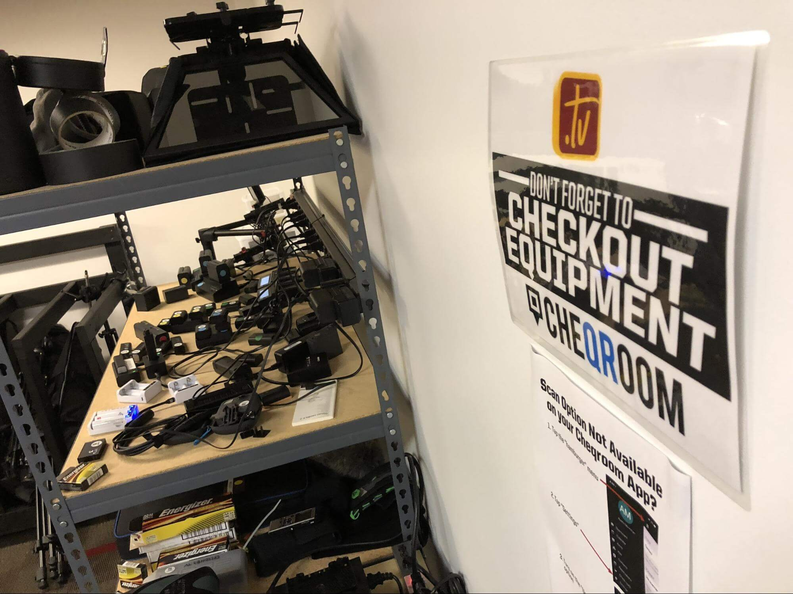

One of our awesome customers from Iowa State University Athletics sent us this great example of a ‘don’t forget to check-out’ poster with the main steps explained underneath. 😎

For the less tech-savvy people among us, sometimes having a manual can help a lot. You could send one out to your team members after the training session which the basic steps explained, so they can always have a look at it first before sending unnecessary emails.

3. Learn to delegate and share the workload

There might come a time where you realize that there are just too many bookings and people borrowing equipment to handle all by yourself. Why not **invite other admins and/or student workers** to help out? You can organize a quick [demo](https://www.cheqroom.com/blog/why-software-demos-make-all-the-difference/) for them and start delegating tasks as soon as they have picked up on the checkout process.

CHEQROOM tip: invite the whole team to the account and allow them to make reservations themselves and check items’ availability. No more unnecessary phone calls or emails back and forth to see if the right gear will be available. If you work in a smaller team and the level of trust is high, you can also decide to give them more access to the account. Increasing their responsibility and diminishing your workload at the same time. 💪

⭐⭐ **NEW**⭐⭐ Is your team forgetful or you can’t help but feel the checkout process could be shorter? You can now use the reservation feature only and just close them when equipment has been brought back. [Read more here](https://help.cheqroom.com/cheqroom-s-key-features-explained/reservations-check-outs-and-custody/closing-reservations)!

4. Make sure your equipment room is functional and well-organized

You are probably thinking: ‘I don’t have time for this right now!’ Or: ‘Where to start?’. But we can assure you, once it’s done, you’ll feel so much better! **An organized room is an organized mind**, right? 😉

Luckily for you, we have bundled some of the [best tips to get your equipment room organized](https://www.cheqroom.com/blog/equipment-room/), after visiting some of our biggest customers. And after going over them, you’ll agree with this: these equipment managers know what they are doing. 😻

5. Implement a time management plan and goals

Dig deeper and find out **where your team is wasting time**. Do they struggle with booking equipment or finding where items are located? Or perhaps the checking in and out process isn’t as clear for everyone… It will take a little more study to get to the root of the problem, but once you find it, you are able to prevent any future issues of the same kind.

In CHEQROOM: use the insights from [our reports](https://www.cheqroom.com/features/equipment-reports/) to identify who is always late with their equipment and set goals for your team members to prevent time waste. You can also use the [availability calendar](https://help.cheqroom.com/cheqroom-s-key-features-explained/calendar/the-availability-calendar-view-for-items) for both Items and Kits to plan resource management ahead.

The other part of implementing a time management plan is efficient maintenance planning. Avoid weekend or late-night calls by **making sure all equipment is in top-notch condition**. Plan downtime and maintenance, and follow-up on warranty dates.

In CHEQROOM: our [Flagging feature](https://help.cheqroom.com/cheqroom-s-key-features-explained/items-and-kits/keeping-track-of-equipment-state-with-flags) allows you and your team members to stay on top of the condition of the equipment.

Allowing users to flag items when they need repair or cleaning will give you some time to plan maintenance. Note that flagged items are still available for checkout. If you want to take them out of circulation until they are up and running again, you’ll want to take them into your custody or assign them to the technician who’s in charge of keeping your inventory top-notch.

8 Tips for better equipment inventory management

Your equipment is a vital part of your business. But are you making the most of it? Read on to discover our 8 tips to improve your business’ effectiveness and [productivity](https://www.cheqroom.com/blog/5-tips-to-super-boost-your-productivity-as-an-equipment-manager/)!

Each tip on its own will save you money and time managing the equipment in your inventory, but the whole is greater than the sum of its parts. If you implement all of the advice below, [equipment inventory management](https://www.cheqroom.com/blog/steps-for-optimizing-inventory-management/) will have a much bigger impact on your business.

1. Know what you have

Do you know exactly what equipment is in your inventory? You might have an idea, but I bet the combined value of all your supporting equipment is higher than you’d expect.

So, you do have an overview. Great. Is it up to date, though? If your list is static and a year or more old, it is worth less than the paper it is printed on.

Your equipment inventory list should be:

* **Complete**: include all of your assets
* **Accurate**: provide enough information – value, location, capabilities, …
* **Up-to-date**: always reflect your changing inventory

[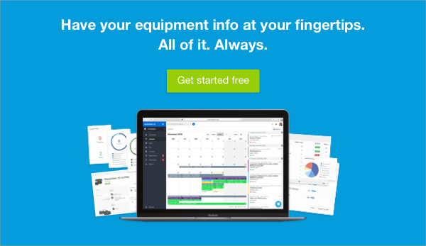](https://cta-service-cms2.hubspot.com/ctas/v2/public/cs/c/?cta_guid=5950afb6-bd11-4145-9096-2ffe6e592781&placement_guid=8e9ff071-2c0e-41d8-b7f2-f815c04db8f4&portal_id=4041600&canon=https%3A%2F%2Fwww.cheqroom.com%2Fblog%2Ftips-efficient-equipment-inventory-management%2F&redirect_url=APefjpEDN73eML6g90KaAmjdjv8SFBZgfpJ7ZKPNgDngW125zqKdDF5Sp771a1u1jDFWu639RAs2W2LLwQrc-Y2RD31mzKd8DIbxqixWLyTbZsA9Cre2LFO1qtI6GA4kVjVtEegyBTtJhBZgFPB6RtvJ_TMRaYOXIGyhvrDTXExlql4HNR1yQAIINFKTcu_TyJB0DRL5Jy949WPOFZWNGciheDodv9XV6trJw8HfCVFkP7xpPa-VAQg&click=0620c577-6902-4b55-8f3e-919a6b1a5d8b&hsutk=3d98f430ff2183d2fc0d0af4d63040a6&signature=AAH58kE5gx-Vvx6_jo2o3Rs6pO5zyyrcVg&utm_referrer=https%3A%2F%2Fwww.cheqroom.com%2Fblog%2F5-reasons-trade-in-excel-for-more-effective-software-tool%2F&__hstc=82073673.3d98f430ff2183d2fc0d0af4d63040a6.1571644847013.1571644847013.1571649210628.2&__hssc=82073673.2.1571649210628&__hsfp=67743208)

2. Track how it is used

Once you know what you have, the next step is knowing exactly how it is being used. There are several questions you should be able to answer for each piece of equipment in your inventory:

* **How** often is it used?
* **Who** uses it?
* **When** and **where** is it used?

When you know what you have and how it is used you can make informed decisions about your current and future equipment management strategy. Time to start making improvements!

3. Right asset, right place, right time

If you have multiple locations, how should you divide your assets between them? An equal division sounds logical but is not effective, as demand for equipment is unlikely to be the same everywhere.

With accurate and up-to-date usage data you can deploy your assets where they are needed most. **Why have equipment gathering dust in one place when there is a shortage elsewhere?**

Demand and supply fluctuate over time as well. Offering a discount might let you make money on items that weren’t going to be used anyway, or you can rent extra equipment yourself to bridge short periods of increased demand.

4. Don’t spend more – spend smarter

One way to ensure that the right equipment is available at the right time is to buy more of everything. But this is inherently wasteful – some of the extra equipment will be put to good use, while the rest will simply sit in storage.

Luckily we can avoid this waste, based on the information we gathered in the earlier steps. **By prioritizing your spending on the equipment that is used most you can get the most bang for your buck!**

5. Fix things before they break

Would you rather:

* **A**: Spend an hour every week making sure your equipment is in great shape
* **B**: Spend a day every month repairing equipment that has broken down

Even looking simply at time spent maintenance is clearly the best choice. And while equipment always seems to break down at the worst time possible, you can plan your maintenance ahead of time.

Equipment that is used all the time is obviously more valuable to your business than equipment that is used once a week. But it is also more likely to break down, so it is in higher need of regular maintenance. Plan maintenance based on need, instead of a fixed schedule for all equipment, to make optimal use of your time.

And because you know when your equipment is most likely to be idle you can schedule maintenance to reduce its impact on the rest of your business.

6. Find underlying issues

If an important piece of equipment breaks down once, it’s an annoyance. But what if it keeps breaking down, over and over? Now that you have data on your equipment, use it!

**Look for trends so you can find underlying issues instead of scratching the surface.**

Perhaps the breakdowns are caused by an employee who didn’t receive the proper training and has been using the equipment the wrong way. In this case replacing the equipment won’t solve the problem – it’ll just cost you more money in the long run!

7. Buy the best

Inevitably equipment will have to be replaced or upgraded. But here again you can use the information you’ve gathered to spend your money smarter.

* Which brands cause the most issues?
* Which equipment is liked best?
* Which equipment loses you the most time and money by breaking down?

8. Use the right equipment inventory system

You can of course try to keep track of this information with pen and paper, for instance [using an equipment signout form](https://www.cheqroom.com/blog/watertight-equipment-sign-out-sheet/) to know who’s using the gear – just as you can still use horse-drawn carts to get around.

Spreadsheets are another option – [but that option has drawbacks as well](https://www.cheqroom.com/blog/5-reasons-trade-in-excel-for-more-effective-software-tool/).

We might be slightly biased, but we truly do believe that using a modern, user-friendly equipment inventory system is the best solution for your business. It automates a lot of the background work, so you can focus on the things that really matter.

We hope that these tips can help you make the most out of your equipment. Spending a bit of time here can have a massive impact on your business’s efficiency and profits!

Bus Ashbe

Shob Lagbe

Alladin & Zeeny

Guardian/ Sentry / Watchman / Custodian / Caretaker